**Can the contradictory effects of contact be reconciled? A study of the non-additive nature of interpersonal and frontier contact.**

Suggested author list (based on contribution across all stages): Durrheim, Dixon, Tredoux, Kerr, Quayle and Gijbertsen

Currently 308 words over limit (n=2308) for into and conclusion combined. I’m sure we can reduce these with careful edit.

The ability of intergroup contact to reduce prejudice must surely list among the most robust effects in social psychology. Numerous studies have shown that cross-group interpersonal contacts and friendships reduce intergroup conflict, threat and prejudice, and promote trust (Pettigrew & Tropp, 2006; Davies et al., 2011). It is not surprising therefore that contact has been the mainstay of social change interventions promoted by social psychologists (Pettigrew & Tropp, 2011). This work relies on a model of change in which the positive effects of contact with particular outgroup members under specific circumstances is generalized to the outgroup as a whole – and may even improve attitudes towards other outgroups. During the past two decades a great deal of research has provided support for the generalized prejudice reduction model of contact interventions. In particular, we have learned that positive attitudes are more likely to generalize to the outgroup as a whole when intergroup contact occurs under conditions where both ingroup and outgroup identities are kept salient, and that social change interventions should therefore promote category salience rather than decategorization or common ingroup identification (Pettigrew & Tropp, 2011).

However, many question still remain about the ability of contact effects to spread to different situations of intergroup contact. If contact reduces prejudice among a mixed group of friends, will non-prejudiced attitudes also be evident in a conflict situation with outgroup acquaintances at the workplace, with troublesome neighbours, or with strangers in public debate? We don’t fully understand the power of prejudice reduction to generalize across different situations because researchers have primarily focused on positive contact in favourable situations (Dixon, Durrheim & Tredoux, 2005). Contact researchers have long recognised that contact under unfavourable conditions can produce undesirable effects (Allport, 1954), and it is for this reason that they have typically studied the effects of equal status, cooperative and intimate contact. This focus is conveniently operationalized in intergroup friendship, which has been shown to have a range of positive outcomes, including intergroup trust, prejudice and anxiety reduction, and a differentiated view of outgroups (Davies et al., 2011). As a consequence of this focus on friendship and optimal contact “the knowledge gained from past contact research is limited by its primary emphasis on positive features of the contact situation” (Pettigrew & Tropp, 2006, p. 767).

A number of avenues of research have explored the negative effects of intergroup contact, and have raised questions about the merits of contact-based change intervention. The negative effects of contact were thrown it sharp relief by Forbes’ (2004) observation that the conflict hotspots are precisely those parts of the world where “different racial and ethnic groups are in the most frequent contact” (p. 71). A substantial body of research in North America, Europe and South Africa supports the argument that regional diversity can promote intergroup conflict, threat and prejudice, and undermines trust (e.g., Durrheim & Dixon, 2010; Fossett & Kiecolt, 1989; Quilian, 1995; Taylor, 1998). A second body of literature suggests that prejudice reduction produced in contact interventions may not generalize to real world situations of conflict. Although the evidence is not conclusive (Paluck & Green, 2009), there are strong suggestions that the salutatory effects quickly dissipate when individuals return to conflict situations such as in Palestine (Hammack, 2011; Maoz, 2012). Finally, research on white flight and the resegregation of neighborhoods and schools suggests that whites are often prepared to accommodate a small minority of minority members, but will leave once the proportion of minority neighbors passes a tipping point or they imagine large scale future influx of minorities (Crowder, 2000; Charles, 2000; Fairlie & Resch, 2002).

The “paradox” or “contradiction” between the two bodies of evidence is about the effects of contact is intriguing. One literature repeatedly shows that contact reduces prejudice while the other shows that contact produces conflict. This raises interesting questions about how these two countervailing effects are managed in practice. The contradictory effects of contact limits the generalizability of contact theory for as much as the desirable effects of optimal contact may or may not spread to non-optimal contact situations, so too, the undesirable effects of non-optimal contact may infect friendship and other optimal contact. So the question about whether the contradictory effects can be reconciled is an important one for researchers that hope to promote social change.

These questions have been investigated recently in two ways. A handful of studies have used multi-level modelling to investigate how the contradictory effects observed by sociologists studying regional diversity and psychologists studying interpersonal contact operate alongside each other (Christ et al. 2014; Dixon, 2006; Stolle et al., 2008). Stolle et al. (2008) and Dixon (2006) found that the contradictory effects operated simultaneously. White Americans who live in close proximity to African Americans are less trusting and more threatened by their neighbours, but interpersonal friendships in such contexts ameliorated these effects. Although Christ et al. (2014) found that the individual and group level effects operated in the same direction and supported each other, they did not directly measure regional diversity. However, multi-level modelling may not be the best way to investigate contradictory effects of contact because diversity at an aggregate level does not necessary mean the groups are in actual contact: “macrolevel diversity should not be equated with actual intergroup contact” (Christ et al., 2014, p. 4). It is possible to live together apart, adopting practices of segregation that reduce contact to a minimum (Tredoux & Dixon, 2009).

Another recent body of work has separated out the negative from the positive valence of contact, and has sought to determine the distinct predictors and effects of each, and how the two affect each other (Paolini, Harwood & Rubin, 2010; Paolini, Harwood, Rubin, Hunsu, Joyce & Hewstone, 2014; Graf, Paolini & Rubin, 2014; Barlow, Paolini, Pedersen, Hornsey, Radke, Harwood, Rubin & Sibley, 2012). This research explains why sites of contact are so often sites of conflict. As they go about their daily lives, people might have both positive and negative contact experiences. However, valence-salience asymmetry makes negative experiences more powerful than positive experiences for resultant intergroup relations. Negative contact experiences have higher category salience and are thus more easily remembered and likely to generalize to new situations than positive contact experiences. As a consequence, as this research shows, “negative contact is disproportionately influential in worsening intergroup relations more than positive contact is in improving them” (Paolini et al., 2014, p. 11).

The multi-level modeling and contact valence research share an assumption in their attempts to reconcile the contradictory effects of contact. Like other researchers in the field, they treat the diverse effects of contact as being additive, and thus as being of a single kind. To illustrate what we mean by this, consider Pettigrew et al. (2011) claim that “contact’s effects are far greater for majorities than for minorities” (p. 278). They assume that the effects of contact are of a single kind, but differ quantitatively between majorities and minorities. Similarly, although the multi-level models typically don’t measure regional level contact, their methods assume that the effects of these two different indices of contact either operate in the same direction, and can be added to each other, or operate in different directions and can be subtracted one from the other. The same is true of contact valence research. However, in contrast to Pettigrew et al.’s (2011) quantitative distinction between contact effects on minorities and majorities, evidence suggests that the effects of contact are qualitatively different for majorities and minorities. Good quality interpersonal contact strengthens social change orientation and associated variables among majorities, but weakens them among minorities (Dixon et al., 2013).

The present study aims to investigate whether the contradictory effects of contact can be reconciled in this manner, using independent measures of two distinct kinds of contact, namely, interpersonal contact and spatial closeness. To this end we surveyed the experiences and opinions of Indian residents of the formal neighborhood of Northdale regarding interpersonal contact with African residents of neighboring informal settlements. We also surveyed the geographic proximity of participants residence form the nearest informal settlement. Northdale was designated an Indian residential area by apartheid legislation in South Africa but the end of apartheid saw the emergence of informal settlements of African shack dwellers on open land in Northdale and surrounds. The non-optimal and conflictual nature of the contact situation has been poignantly highlighted by ongoing conflict between the formal and informal residents over ‘illegal electricity connections’, crime, and falling house prices. Our research sought to understand how the contradictions are reconciled between the prejudice-arousing threats of physical closeness and the prejudice-reducing effects of positive interpersonal contact. Both the positive and negative effects may want to generalize to new situations but are limited by each other. How then is the psychological condition of contradictory effects managed by people? How does it translate into outcomes? When?

In the light of previous findings of the contradictory effects of group and individual level contact, we hypothesized that physical closeness would be associated with higher levels of prejudice, but that positive interpersonal contact would be associated with lower levels of prejudice. We expected that these prejudice effects would be mediated by the same factors, namely, threat, and empathy.

**Method**

**Sample**

We imagined a physical closeness would be experienced by those in the immediate vicinity of the informal settlement as living on or near the frontier, with the threats and possibilities this affords. Accordingly, we subdivided the Northdale population into three strata – immediate neighbours of the Hlalakahle informal settlement, residences in eyeshot of an informal settlement, and the remainder – and we selected a stratified random sample, oversampling households in the two closer strata. We used the last birthday method (O’Rourke & Blair, 1983) to identify individual adult respondents in selected households. The sample consisted of n = 365 self-identified Indian adult South African residents (185 females) whose mean age was 45.43 years (SD = 14.97), ranging from 18 to 84 years. We were unable to contact members of 53 households, who were not at home on 3 occasions. A further 82 eligible people refused to participate in the survey. Together, this gives us a non-response rate of .27. The final sample represents 4.36% of the residential households in Northdale.

**Procedure**

Questionnaires were administered by seven research assistants who were Indian students living in Northdale or surrounding suburbs. They visited selected households, selected individual participants, and administered the questionnaire by asking participants to complete the paper-and-pencil survey themselves. In a small minority of cases where participants were not able to complete questionnaire themselves, the research assistants were instructed to read the questions out aloud while marking participants’ answers in the questionnaire.

**Materials (Colin, please check this closely, making changes to reflect the measure you used)**

The survey consisted of items adapted from measures used in previous research, as well as items designed to capture features specific to the Northdale context. Participants responded on Likert-type scales, with anchors ranging from “strongly disagree” to “strongly agree”, which were reverse scored where necessary. Internal reliability of individual scales was assessed with coefficient omega (Zinbarg, Revelle, Yoval and Li, 2005), or inter-item correlations (for two item scales), and the combined measurement model was assessed as part of the Structural Equation modeling reported later.

*Contact Quantity*. We designed and used two items, which asked respondents to report the amount of contact they had in their day-to-day lives. The inter-item correlation was 0.43

*Contact Quality.* We used three items adapted from Islam and Hewstone’s (1993) Qualitative Aspects of Contact scale (ω = .89): “When I come into contact with people from informal settlements, we generally cooperate well with each other”, “When I come into contact with people from informal settlements, we almost always interact as equals”, and “When I come into contact with people from informal settlements, contact is almost always friendly”.

*Contact Avoidance.* We designed three items to measure the degree to which participants avoided contact with informal settlers (ω = .87): “Do you ever change your routine to avoid contact with informal settlement residents?”, “When walking or driving do you ever go out of your way to avoid areas where you would encounter residents of the informal settlement?”, and “When you are alone do you try to avoid encountering residents of the informal settlement?”.

*Closeness*. We operationalized physical closeness in terms of how close the Indian participants lived to the nearest informal settlement, and their subjective perceptions of closeness and their ability to see, hear and smell their neighbors. We created a composite measure of physical closeness, using the following indicators: (1) Physical closeness, , calculated using Google maps, and scaled to range from 0 to 1; and the visceral experience of closeness indicated by self-reported ability to (2) see, (3) hear, or (4) smell an informal settlement form their house or garden (all coded dichotomously). The summed scale showed satisfactory internal reliability (ω = .79)

*Prejudice*. Prejudice towards people who live in informal settlements was measured by means of a five-item semantic differential scale (Zanna, 1994) on which respondents rated (on 10 point scales) how they felt about members of the outgroup: (1) Negative – Positive, (2) Cold – Warm, (3) Hostile – Friendly, (4) Suspicious – Trusting, (5) Disrespect – Respect. Internal reliability was satisfactory (ω = .81)

*Threat*. We operationalised threat in physical terms, using a 3-item scale adapted from Schmidt et al (1998): (1) I worry about crime committed by informal settlement residents; (2) I worry about being physically attacked by informal settlement residents; (3) I worry about my personal property being damaged by informal settlement residents. The summed scale showed satisfactory internal reliability (ω = .92)

*Empathy*. We used Wang et al.’s (2003) four-item empathic awareness scale: (1) I am aware of how society differentially treats people who live in informal settlements; (2) I recognize that the media often portrays residents of informal settlements negatively, (3) I can see how people who live in informal settlements are systematically oppressed in our society; (4) I am aware of institutional barriers (e.g., restricted access to jobs and healthcare) that discriminate against people who live in informal settlements (ω = .84).

**Results (Colin, this is the old results section, unedited. I leave the redraft to you my bru! Please note that we are pressed for space in the intro and cocnuson, which together cannon exceed 2000 words. So we need to do as much interpretation of the findings as we can here in the results section – the word length of the methods and results section does not factor into the article length limit. )**

Table 1 reports descriptive statistics, and inter-correlations of variables. It is notable that the sample experienced high levels of threat – a mean of 3.15 on a 4 point scale.

|  |
| --- |
| Insert Table 1 about here |

Not surprisingly, the closer participants lived to an informal settlement, the more threat they experienced (r=.27, p < .0001, 95% CI = .17;.36). The relationship is well illustrated graphically in Figure 1, which shows the geographic distribution of threat in Northdale.[1] The map exposes the frontier, showing that pockets of threat exist in areas in the immediate proximity to or in eyeshot of the informal settlements. It also shows how the physical geography of Northdale affects the experience of threat. Most notably, the lowest levels of threat are experienced by residents living in the regions geographically separated from the informal settlements by streams.

|  |
| --- |
| Insert Figure 1 about here |

There is something disconcerting about this negative consequence of closeness. This is because closeness is also presumably required in order that intergroup contact occur, and we know that the effect of contact on intergroup relations is positive. On the other hand, several researchers have pointed out that contact can have negative effects in certain circumstances, and still others who study intergroup encounter in naturalistic settings have shown that groups often avoid coming into contact with each other (see, for instance, Finchilescu & Tredoux, 2007). We therefore postulated a model that has two routes to prejudice, namely one through physical threat and contact avoidance, which are driven in sequence by physical proximity, and another through frequent intergroup contact that is positive in quality, and which increases empathy, and in turn, reduces prejudice. This recursive model is shown in Figure x, and we tested it with Structural Equation methods, using the ‘lavaan’ package (Rosseel, 2012) in R (R Core Team, 2014). Although Figure x implicitly makes claims about the pattern of direct and indirect effects between the variables in question (e.g. that the effect of contact quality on prejudice is indirect, by driving up the frequency of contact), many of these are the outcome of pruning paths from the model on the basis of the SEM results. The Figure thus embodies the key theoretical assertions of separate paths to prejudice, as well as some post-hoc refinement.

To test the model we used the SEM function in LAVAAN. Standard measures of SEM fit were well within conventionally recommended levels (cf. Kline, 2010; RMSEA = .045 (90% CI for RMSEA .035 to .055), CFI = .97, TLI= .96, SRMR = .06), showing good – but not perfect fit to the data (a minimum function χ2 test showed statistically significant deviation from perfect fit; χ2ML= 281.3, df = 180). Detailed parameters of the structural model are shown in Table x, and Figure x shows the paths graphically.

Of course, part of our model generation has been post-hoc in nature, and could be said to capitalize on chance. As a partial check on this, we attempted an internal cross-validation of model B: we randomly split the dataset into equally sized training and testing sets, and re-ran the SEM on each set. We computed the ECVI index (Expected Cross Validation Index; West, Taylor & Wu, 2012) for each model, and also compared the fit statistics, as well as the parameter estimates. The SEM models were similar, yielding RMSEA estimates of .05 and .06 respectively, the 90% confidence intervals overlapping substantially, leading to the conclusion that there was insufficient evidence to reject the hypothesis that they were of different size. The ECVI coefficients were .78 and .82 respectively, suggesting similar models. Of course, a more complete check on the validity of the models would be to replicate them with a different sample, but this is beyond our means at present.

Fit statistics for structural equation models are not always sufficiently diagnostic (Kline, 2010), and so we examined standardized residuals and modification indices for model B. Approximately 8% of the residuals were larger than notional 95% cut points on a cumulative normal distribution, and none fell outside Bonferroni corrected cut points. One modification index was larger than 10, the notional cut-off in the MPlus modelling program (Muthén & Muthén, 2011).

To further clarify these results, in the next section we outline the strength and direction of the paths included in model B (see Table 2 for a full comparative summary of fit statistics and coefficients for both models).

**- Place Figure 4 here –**

**- Place Table 2 here -**

Contact Quality and Perceived Outgroup Discrimination. As anticipated, the path coefficient relating contact quality and perceived discrimination was statistically significant (b = .32, p < .001). That is, the more positively experiences of contact are evaluated, the more that Indian residents recognize that the informal settlers are victims of discrimination.

Contact Quality, Perceived Outgroup Discrimination and Policy Support. We found support for our hypotheses that policy support (political attitudes) is driven by contact quality (b = .20, p< .002) and by perceived outgroup discrimination (b = .28, p < .008).

Contact Quality, Perceived Outgroup Discrimination and Collective Action. Finally, we anticipated that the paths connecting to collective action tendencies from contact quality and outgroup discrimination would be positive, and significant. The analysis of model B supports these hypotheses: There are significant positive relationships between contact quality and collective action tendencies (b = .17, p < .05), suggesting that higher quality contact is associated with higher collective action tendencies in our Indian participants. Similarly, the path connecting perceived outgroup discrimination directly to collective action is statistically significant (b = .78, p < .001).

In sum, our analysis of direct effects suggests that higher quality of contact leads directly on the one hand to political attitudes that are positively receptive to informal settlers, and to support for collective action on their behalf. On the other hand, higher quality of contact also leads to heightened perceptions that informal settlers are discriminated against, which in turn leads – independently - to heightened empathy for settlers, and to support for collective action on their behalf. Notably, heightened perceptions of outgroup discrimination and heightened empathy do not lead to more positive political attitudes towards settlers. We must stress that this interpretation is tentative, as cross-sectional SEM models of the kind we report do not warrant causal conclusions.

There are also indirect effects of quality of contact in Model B, specifically on collective action (through perceived outgroup discrimination), and on perspective taking/empathy (also through perceived outgroup discrimination). These were computed in LAVAAN, and both found to be statistically significant (b = .252, z = 3.9, p <.001; and b = .136, z = 3.7, p <.001).

We modelled the way closeness affected prejudice through the mediators of threat, empathy and negative emotions. We first estimated the saturated model by specifying all paths between standardized measures of closeness, the mediators and the outcomes. We then removed all paths with p-values >.05. Closeness was not directly related with prejudice (r=.04) but the resultant model (see Figure 2) shows that an indirect relationship existed between closeness and prejudice, entirely mediated by experiences of threat and negative emotions. Individuals who lived close to an informal settlement felt threatened and negative emotions, which in turn were associated with higher levels of prejudice in comparison with those who lived further away.

|  |
| --- |
| Insert Figure 2 about here |

We used to same method to model the way contact quality affected prejudice through the mediators of threat, empathy and negative emotions. Once we had defined a model for the sample as a whole, we examined the moderating effect of closeness by replicating the analysis for participants who lived close to (weights above the paths in Figure 3) or far from an informal settlement (weights below the paths in Figure 3). We did this by using a mean split of the composite closeness variable.

The RMSEA for the model for participants living in the immediate proximity of informal settlement was not significant. However, contact quality was associated with threat, empathy and prejudice.

Neither threat nor empathy mediated the relationship between contact quality and prejudice. Good quality contact with residents of informal settlements – mostly likely in employment relationship with domestic workers – reduced prejudice toward residents of informal settlements but this relationship was not affected by the decreased threat and increase empathy that was also associated with good quality contact. Presumably these residents already experienced high levels of threat associated with falling house prices and the possibility of crime and negative emotions linked being disturbed by noise, affected by electricity theft, etc. In this context, good quality contact reduces prejudice and promotes empathy with the plight of people living in informal settlements, but these effects are independent of and do no ameliorate the negative effects of threat and negative emotions.

The model for participants living further away from informal settlements is similar. There is a strong direct negative effect between contact quality and prejudice. In addition, good quality contact affects prejudice by reducing negative emotions. At the same time quality contact is associated with reduced thread and increased empathy, but these mediators were not associated with prejudice.

|  |
| --- |
| Insert Figure 3 about here |

**Conclusion**

The contact literature has moved on from asking whether contact reduces prejudice. To form the basis of effective interventions we need to understand how the effects of different kinds of contact operate alongside each other. Following research that has explored contradictory effects of regional diversity and interpersonal contact, and positive and negatively valenced interpersonal contacts, we set out to determine whether contradictory effects of contact can be reconciled. Our research has taught us that this might have been the wrong question. The effects might not be able to be reconciled in the sense that the positive and negative effects and simply be added to each other. According to the wisdom of the prejudice reduction models of social change we might be able to get around the problem of negative contact by orchestrating more positive contact, as suggested by Christ, et al., (2014) and (Graf et al., 2014).

In contrast, our data show that different kinds of contact not only have different valence and outcomes, but they follow different paths to and are differentially related to prejudice.

On the one hand, by living on the boundaries between groups, neighbours that could see, smell, and hear the informal settlement experienced a form of contact we designated ‘frontier contact’. frontier contact, living on the boundaries between groups. We get a glimpse of the social psychological experience of frontier contact from the map depicting the geographic distribution of threat across Northdale (Figure 1). Residents living in the immediate physical proximity or in eyeshot of an informal settlement were more likely to feel threatened by the possibility of crime, physical attack and damage to property. On the other hand, those areas of the neighbourhood that were physically separated from informal settlements by streams were far less to experience such threat.

The results of our modelling showed that interpersonal and frontier contact were empirically distinct, and each established different paths with prejudice. Figure 2 shows that frontier contact was not directly correlated with prejudice, but had a powerful effect on prejudice through the mediating variables of threat and contact avoidance. Staying near to an informal settlement promoted threat and a desire to avoid outgroup contacts, which in turn were associated with increased prejudice. It is unlikely that more residents with higher levels of threat and contact avoidance motives chose to live near informal settlements, giving grounds to believe that the effects are in the causal direction depicted by the model.

In direct contrast to these effects and in line with the expectations of contact theory, good quality interpersonal contact was directly associated with reduced prejudice. This effect was equally strong for residents living in the threat regions near to or far away from the informal settlements. In addition for those living far from informal settlements, the prejudice reduction effect of good quality interpersonal contact was attributable to reduce negative emotions. Surprisingly, the reduced threat and increased empathy associated with good quality contact did not translate into reduced prejudice, either among the either sample living close to or far from an informal settlement.

Together, the results paint a picture of complex contradictory experience of intergroup contact. Frontier contact promotes threat, contact avoidance and prejudice, whereas interpersonal contact reduces prejudice. The contradictory effects operate alongside each other, without one effect generalizing to gradually supersede or take over the other. The residents of Northdale manifested a remarkable ability to partition and compartmentalize rather than generalize the contradictory effects. Living near to an informal settlement prompted fears about crime and attack, and these translated into contact avoidance and increase prejudice. On the other hand, good quality contact with individuals from the informal settlement promoted empathy for the plight of people living in these conditions, and it reduced prejudice. However, these beneficial effects do not eradicate the threat associated with potential criminal activity emanating from the informal settlements.

These findings help us to think differently about contact-based change interventions. Perhaps the traditional prejudice reduction approaches are at once too optimistic and pessimistic. They hope to eradicate prejudice through generalized effects of positive contact but then offer no hope when real world contact produces negative experiences. The compartmentalization of contradictory contact effects suggests alternative strategies to promote social change. For example, efforts to reduce prejudice through good quality contact interventions in Northdale might be doomed to failure given the nature of the real and immediate threats. Nonetheless, the empathy that these relatively poor and historically oppressed Indian residents have with their even poorer, marginalized and oppressed neighbours is potentially the foundation of solidarity between these groups and the basis for collective action. The question then is how to foster empathy, solidarity and the kind of collective action that would promote genuine social change? (see Dixon et al., in press)

**References**

Allport, G.W. (1954). *The nature of prejudice*. Garden City, NY: Doubleday.

Barlow, F. K., Paolini, S., Pedersen, A., Hornsey, M. J., Radke, H. R. M., Harwood, J., Rubin, M., & Sibley, C. G. (2012). The contact caveat: Negative contact predicts increased prejudice more than positive contact predicts reduced prejudice. *Personality and Social Psychology Bulletin*, *38*, 1629–1643. doi: 10.1177/0146167212457953

Brown, R., & Hewstone, M. (2005). An integrative theory of intergroup contact. In: M.P. Zanna (ed.) *Advances in Experimental Social Psychology.* Academic Press, San Diego, pp. 255-343.

Charles, C. Z. (2000). Neighborhood racial-composition preferences: Evidence from a multiethnic metropolis. *Social Problems*, *47*, 379-407.

Christ. O., Schmid, C., Lolliot, S., Swart, H., Stollee, D., Tausch, N., Ramiah, A., Wagner, U., Vertovech, S., & Hewstone, M. (2014). Contextual effect of positive intergroup contact on outgroup prejudice. *Proceedings of the National Academy of Sciences*. doi: 10.1073/pnas.1320901111

Crowder, K. (2000). The racial context of white mobility: An individual-level analysis of the white flight hypothesis. *Social Science Research*, *29*, 223–57.

Davies, K., Tropp, L. R., Aron, A., Pettigrew, T. F., & Wright, S. C. (2011). Cross-group friendships and intergroup attitudes: A meta-analytic review. *Personality and Social Psychology Review*, *15*, 332-351.

Dixon, J. C. (2006). The ties that bind and those that don't: Toward reconciling group threat and contact theories of prejudice. *Social Forces*, *84*, 2179-220.

Dixon, J., Durrheim, K., & Tredoux, C. (2005). A reality check for the contact hypothesis. *American Psychologist, 60*, 697-711.

Dixon, J., Durrheim, K., Kerr, P., & Thomae, M. (2013). ‘What’s so funny ‘bout peace, love and understanding’? Further reflections on the limits of prejudice reduction as a model of social change**.** Journal of Social and Political Psychology.

Dixon, J., Durrheim, K., Thomae, M., Tredoux, C., & Kerr, P. (in press). Divide and rule, unite and resist: Contact, collective action and policy attitudes amongst historically disadvantaged groups. *Journal of Social Issues*.

Durrheim, K., & Dixon, J. (2010). Racial Contact and Change in South Africa. *Journal of Social Issues*, *66*, 273-288.

Fairlie, R. W., Resch, A. M., (200). Is there ‘white ﬂight’ into private schools? Evidence from the

National Educational Longitudinal Survey. Review of Economics and Statistics,

Forbes, H. (2004). Ethnic conflict and the contact hypothesis. In Y. T. Lee, C. McAuley, F. Moghaddam, & S.Worchel (Eds.), *The psychology of ethnic and cultural conflict* (pp. 69–88). New York: Praeger.

Fossett, M. & Kiecolt, K. J. (1989). The relative size of minority populations and white racial attitudes. *Social Science Quarterly*, *70*, 820-35.

Graf, S., Paolini, S., & Rubin, M. (2014). Negative intergroup contact is more influential, but positive intergroup contact is more common: Assessing contact prominence and contact prevalence in five

Central European countries. *European Journal of Social Psychology*, DOI: 10.1002/ejsp.2052.

Hammack, P. L. (2011). *Narrative and the politics of identity: The cultural psychology of Israeli and Palestinian youth*. New York: Oxford University Press.

Islam, M. R., & Hewstone, M. (1993). Dimensions of contact as predictors of intergroup anxiety, perceived out-group variability, and outgroup attitude: An integrative model. *Personality and Social Psychology Bulletin, 19*, 700-710.

Maoz, I. (2012). Contact and social change in an ongoing asymmetrical conflict: four social-psychological models of reconciliation-aimed planned encounters between Israeli Jews and Palestinians. In J. Dixon & M. Levine (Eds). *Beyond the prejudice problematic*. Cambridge. Cambridge University Press.

O’Rourke, D. & Blair, J. (1983). Improving random respondent selection in telephone surveys. *Journal of Marketing Research*, *20*, 428-432

Paluck, E. L., & Green, D. P. (2009). Prejudice reduction: What works? A review and assessment of research and practice. *Annual Review of Psychology*, *60*, 339-367.

Paolini, S., Harwood, J., & Rubin, M. (2010). Negative intergroup contact makes group memberships salient: Explaining why intergroup conflict endures. *Personality and Social Psychology Bulletin*, *36*, 1723–1738. doi:10.1177/0146167210388667

Paolini, S., Harwood, J., Rubin, M., Husnu, S., Joyce, N., & Hewstone, M. (2014). Positive and extensive intergroup contact in the past buffers against the disproportionate impact of negative contact in the present. *European Journal of Social Psychology*. doi: 10.1002/ejsp.2029

Pettigrew, T.F. & Tropp, L.R. (2006). A Meta-analytic test of intergroup contact theory. *Journal of Personality and Social Psychology, 90,* 751-783.

Pettigrew, T. F., & Tropp, L. R. (2011). *When groups meet: The dynamics of intergroup conflict*. Philadelphia, PA: Psychology Press.

Pettigrew, T. F., Tropp, L. R., Wagner, U., & Christ, O. (2011). Recent advances in intergroup contact theory. *International Journal of Intercultural Relations*, *35*, 271-280.

Quilian, L. (1995). Prejudice as a response to perceived group threat: Population composition and anti-immigrant and racial prejudice in Europe. *American Sociological Review*, *60*, 586-611.

Stolle, D., Soroka, S., &Johnston, R. (2008). When does diversity erode trust? Neighborhood diversity, interpersonal trust and the mediating effect of social interactions. *Political Studies*, *56*, 57–75.

Taylor, M. C., (1998). How white attitudes vary with the racial composition of local populations: Numbers count. *American Sociological Review*, *63*, 512-535.

Tredoux, C. G., & Dixon, J. (2009). Mapping the multiple contexts of racial isolation: The case of Long Street, Cape Town. Urban Studies, *46*, 761–777. DOI: 10.1177/0042098009102128

Wang, Y., Davidson, M., Yakushko. O.F., Savoy, H.B., Tan, J.A., & Bleier, J. K. (2003). The scale of ethnocultural empathy: Development, validation, and reliability. *Journal of Counseling Psychology*, *50*, 221–234.

Zanna, M. P. (1994). On the nature of prejudice. *Canadian Psychology*, *35*, 11-23.

Zinbarg, R. E., Revelle, W., Yovel, I., & Li, W. (2005). [Cronbach’s α, Revelle’s β, and McDonald’s ω](http://scholar.google.co.za/citations?view_op=view_citation&hl=en&user=293jbW0AAAAJ&citation_for_view=293jbW0AAAAJ:UeHWp8X0CEIC)[H](http://scholar.google.co.za/citations?view_op=view_citation&hl=en&user=293jbW0AAAAJ&citation_for_view=293jbW0AAAAJ:UeHWp8X0CEIC)[: Their relations with each other and two alternative conceptualizations of reliability](http://scholar.google.co.za/citations?view_op=view_citation&hl=en&user=293jbW0AAAAJ&citation_for_view=293jbW0AAAAJ:UeHWp8X0CEIC). *Psychometrika 70*, 123-133.

**Table 1**. Descriptive statistics and inter-correlations of variables

|  |  |  |  |  |  |  |  |  |  |  |
| --- | --- | --- | --- | --- | --- | --- | --- | --- | --- | --- |
|  | Mean | SD | ω✝ |  | Threat | Empathy | Prejudice | Contact Quantity | Contact Avoidance | Contact Quality |
| Closeness | 2.26 | 1.32 | 0.79 |  | 0.27** | -0.02 | 0.06 | -0.05 | 0.29** | -0.10 |
| Threat | 3.15 | 0.86 | 0.92 |  |  | 0.04 | 0.27** | -0.22** | 0.49** | -0.30** |
| Empathy | 2.42 | 0.85 | 0.84 |  |  |  | -0.19* | 0.21** | -0.07 | 0.26** |
| Prejudice | 2.69 | 0.97 | 0.81 |  |  |  |  | -0.35** | 0.27** | -0.37** |
| Contact Quantity | 2.14 | 0.82 | 0.60ⱡ |  |  |  |  |  | -0.22** | 0.40** |
| Contact Avoidance | 1.74 | 1.29 | 0.87 |  |  |  |  |  |  | -0.40** |
| Contact Quality | 2.17 | 0.89 | 0.89 |  |  |  |  |  |  |  |

Note. All measures are scored with range 0 to 4. * p < .001 ** p < .0001

ⱡ This two item scale has inter-item r = 0.43

✝ Omega is an ostensibly better measure of scale reliability than Alpha (Zinbarg, Revelle, Yovel & Li, 2005)

Table x Fit statistics and unstandardized regression weights for a Structural Equation model showing positive and negative routes to prejudice.

|  |  |  |
| --- | --- | --- |
| Fit statistics | Value | |
| *χ2ML* | 281.3 | |
| df | 180 | |
| CFI | .97 | |
| TLI | .96 | |
| RMSEA | .045 | |
| 90% CI RMSEA | .035; .055 | |
| SRMR | .06 | |
| AIC | 2264.49 | |
| N | 273 | |
|  | *b (s.e.)* | *p<* |
| Contact quantity 🡨 Contact quality | .69 (.11) | .001 |
| Contact quality 🡨 Threat | -.36 (.08) | .001 |
| Threat 🡨 Closeness | .70 (.14) | .001 |
| Empathy 🡨 Contact quality | .23 (.05) | .001 |
| Contact avoidance 🡨 Threat | .67 (.10) | .001 |
| Contact avoidance 🡨 Contact quality | -.38 (.08) | .001 |
| Prejudice 🡨 Contact quantity | -.44 (.09) | .001 |
| Prejudice 🡨 Contact avoidance | .22 (.07) | .001 |
|  |  |  |
| Paths excluded from model (n.s. paths) |  |  |
|  |  |  |
|  |  |  |
|  |  |  |
|  |  |  |
|  |  |  |
|  |  |  |
|  |  |  |
|  |  |  |

**Figure 1.** Experiences of threat in Northdale.

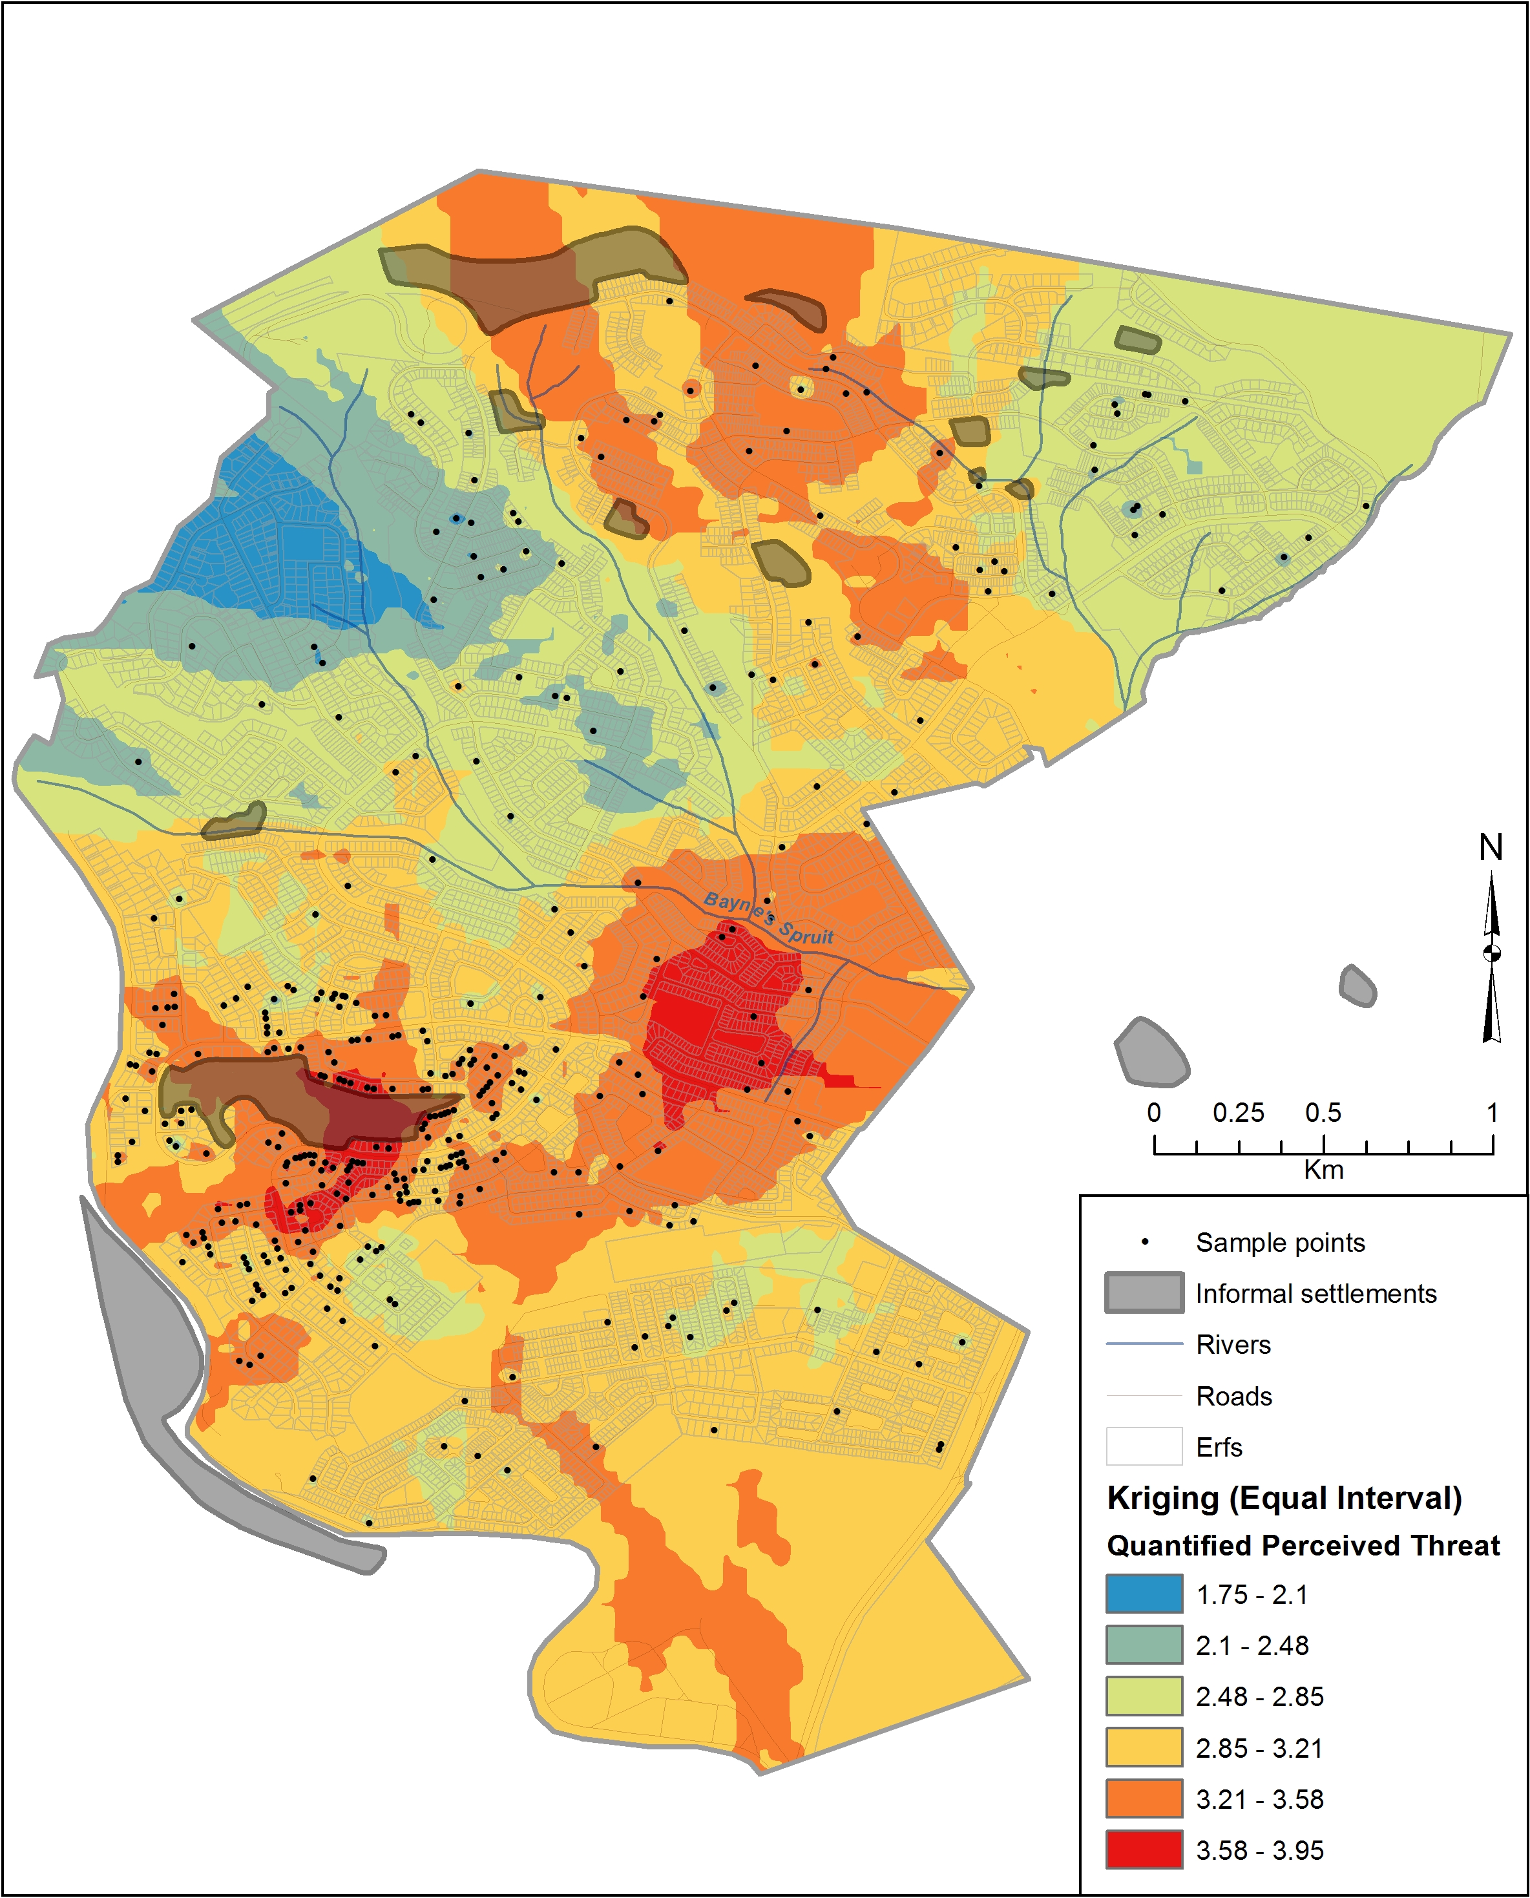

**Figure 2.** Model of the effects of closeness to an informal settlement

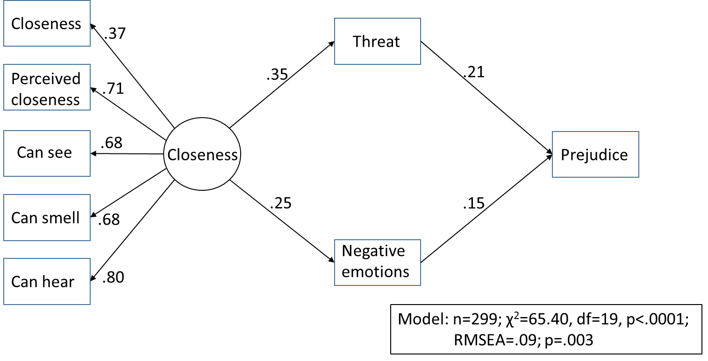

**Figure 3**. Model of the effects of good quality contact with informal settlement residents.

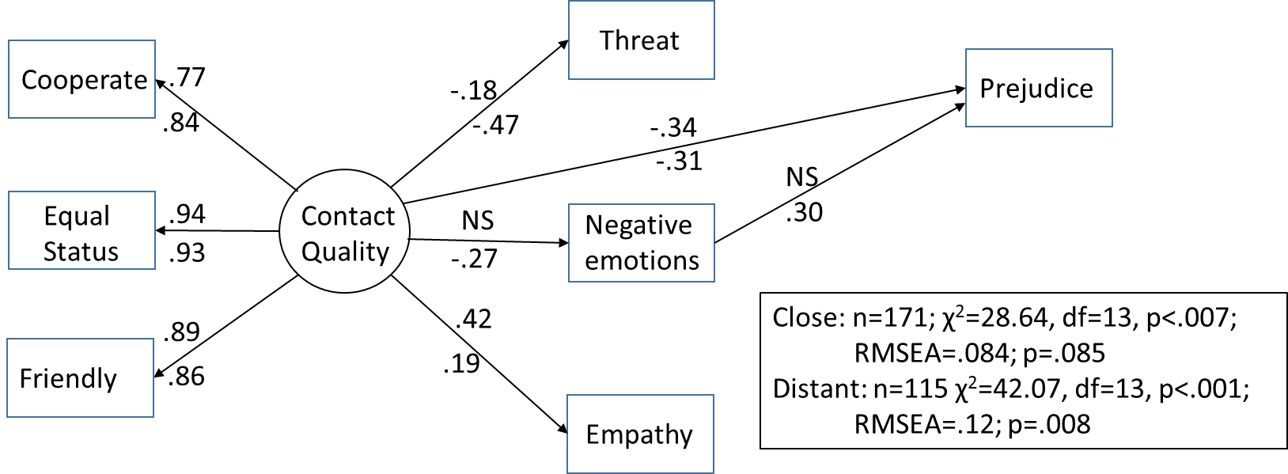

Note. Standardized regression coefficients for the model for participants living close to informal settlements are represented above the paths; Standardized regression coefficients for the model for participants living close to informal settlements are represented below the paths

1. The analysis was undertaken in ArcInfo 10.2 using an Ordinary Kriging interpolation with a spherical algorithm utilizing a spatially variable search window of 12 data points. In essence this means that for closely clustered points the spatial extent of overlapping points is smaller than those further apart but the standard interpolation utilizes the 12 closest points around each pixel to create the surface. Raster resolution is 10 metres.

   The scientific explanation of Kriging is as follows: Unlike plain Inverse distance weighting which assumes the influence of a point diminishes away from the point at a constant rate, Kriging factors in distance and direction when calculating spatial correlation. It statistically examines the data, then fits a modelled variogram and using this variogram it creates a surface. It is most appropriate where there are spatial correlations or relationships between points particularly distance and direction, such as modelling wetlands based on water depth or soil type.